Chip back potential is the level which bulk silicon is maintained by on-chip connection, or it is the level to which the chip back must be connected when specifically stated below. If no potential is given the chip back should be isolated.

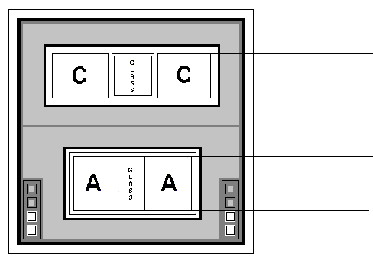
.022”
.022”
0.0045”
0.004”

Anode and Cathode on Top
Silicon Epitaxial Layer Construction for Low Series Resistance
Suried Zener Junction for High Reliablility
Silicon Nitride Passivation

Top Material: Al
Backside Material: Au
Bond Pad Size: .004” min.
Backside Potential: Anode & Cathode on Top Surface
Mask Ref: ZHP

APPROVED BY: DK DIE SIZE .022” X .022” DATE: 8/31/21
MFG: ALLEGRO / SPRAGUE THICKNESS .010” P/N: 1N4579A
DG 10.1.2

Rev B, 7/19/02

